2012 EVENTS

** Feb 17-19 Winter Camp, Camp George

** March 23-25 Spring Drill, Camp George

** May 4-6 150th McDowell, reenactment
http://www.battleofmcdowell.org/

* June 14-16 The 7 Days Campaign, reenactment
http://www.leetakescommand.com/

* August 31-Sep1 Potomac River Crossing Living History

** September 7-9 150th Antietam , reenactment
http://www.marylandmymaryland.org/

Other events members may also attend
Mar29-Apr1 150th Shiloh reenactment (Federal)

Sep 6: Recreation of Rosenstock Photo, Frederick
MD

October 5-7 Perryville KY, Southern Division
event

October 6-7 Waterford VA, Paid Event

* = Brigade recommended Events
** Bold = Max Effort Brigade Events

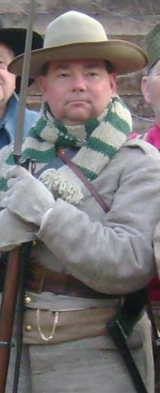

4th Virginia Infantry
Company A

“Wythe Grays”

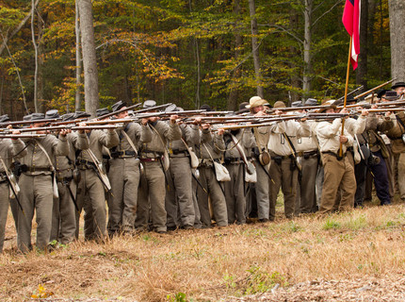

A proud member of
The Stonewall Brigade

About the Wythe Grays

The 4th Virginia, Company A “Wythe Grays” is a progressive Confederate reenactment unit. We are a laid back group that strives for high authentic standards but is not “in your face” about it.

We have members throughout Maryland, Virginia, West Virginia, Pennsylvania, and even Colorado.

The 4th Virginia is a proud founding member of The Stonewall Brigade.



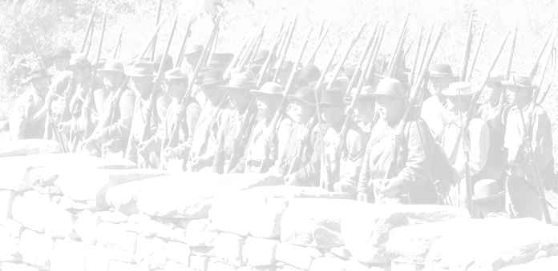
About The Stonewall Brigade

The Stonewall Brigade is an umbrella reenactment organization. The Stonewall Brigade consists of several reenactment units to work together to form a cohesive unit at living histories and reenactments. The brigade Officers and NCO are elected from the memberships of all reenactment units within the brigade.
The Stonewall brigade was formed in 1980 by the 4th Virginia Company A and the 33rd Virginia Company E. Since 1980 the 2nd Virginia Co. A, 5th Virginia Co. A, 27th Virginia Co. C, 27th Virginia Co. D, 33rd Virginia Co. A, 33rd Virginia Co. H, and The Liberty Hall Fifes and Drums have joined the brigade. We all have several things in common, a love of Civil War history and a desire to do things right. But most importantly we enjoy coming together 6 or 7 times each year being with our friends and putting on the best infantry impression that contemporary research and resources will allow. In 2010, the SWB joined the Southern Division to work more closely with other campaigner units.
Contact Information

If you are interested in learning more about joining the Wythe Grays or would like to take advantage of our supply of loaner gear to fall in with us for an event, please contact one of the following individuals:

Brad Ireland
443-622-2999
cprljohnivey@aol.com

Victor Sarna
304-897-7756
map12346@hardynet.com

www.stonewallbrigade.com
www.southerndivision.org

