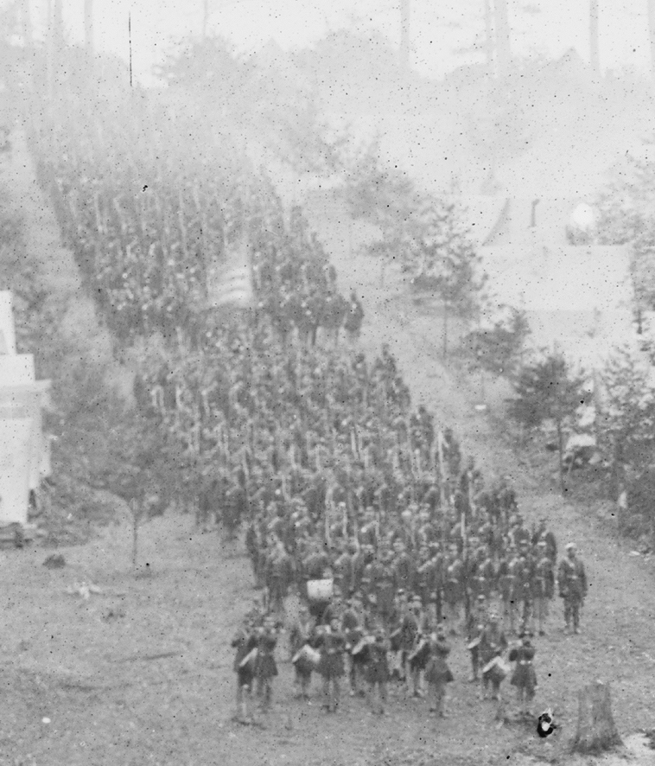

Belle Plain, Virginia. Camp of 150th Pennsylvania Infantry.
CREATED/PUBLISHED
1863 Mar.
NOTES
Caption from negative sleeve: Camp of 150th Pa., March 1863 3 weeks before the Battle of Chancellorsville.
Miller, vol. 2, p. 103.
Two plates form left (LC-B811-297A) and right (LC-B811-297B) halves of a stereograph pair.
Forms part of Civil War glass negative collection (Library of Congress).
SUBJECTS
United States--History--Civil War, 1861-1865
Stereographs--1860-1870.
Glass negatives--1860-1870.
MEDIUM
1 negative (2 plates) : glass, stereograph, wet collodion.
CALL NUMBER
LC-B811- 297
REPRODUCTION NUMBER
LC-DIG-cwpb-00935 DLC (digital file from original neg. of left half)
LC-DIG-cwpb-00936 DLC (digital file from original neg. of right half)
SPECIAL TERMS OF USE
No known restrictions on publication.
REPOSITORY
Library of Congress Prints and Photographs Division Washington, D.C. 20540 USA
DIGITAL ID
(digital file from original neg. of left half) cwpb 00935 http://hdl.loc.gov/loc.pnp/cwpb.00935
(digital file from original neg. of right half) cwpb 00936 http://hdl.loc.gov/loc.pnp/cwpb.00936

