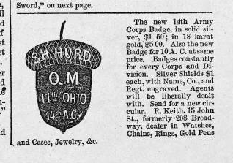

Source: Harper’s Illustrated Weekly, 11 June 1864, p. 382.

Samuel Hurd (First_Last)
Regiment Name 17 Ohio Infantry
Side Union
Company F&S
Soldier's Rank_In Pvt.
Soldier's Rank_Out 1" Lt. & R.Q.M.
Alternate Name Samuel H./Hurd
Notes
Film Number M552 roll 53

Samuel H. Hurd (First_Last)
Regiment Name 17 Ohio Infantry. (3 Months 1861.)
Side Union
Company B
Soldier's Rank_In Pvt.
Soldier's Rank_Out Pvt.
Alternate Name
Notes
Film Number M552 roll 53

