Lindenwood
Lindenwood University St. Charles, Missouri
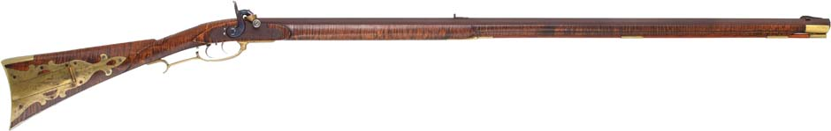
Spring 2008
Announcing a special Daniel Boone Campus Adult Education course:
Introduction to Gunsmithing
Working with master gunsmith James Duncan, students will build a complete, functional muzzle loading firearm from parts they order. The student may select a firearm as fancy or practical as they wish depending on their interest and personal budget. Students are recommended to purchase their firearms parts from a reputable dealer recommended by the instructor. These can range from $450 and up. Students will meet for orientation and to order parts on Jan 22, 2008 on the main Lindenwood campus from 6 pm to 9 pm. The remainder of the classes will be conducted at the Daniel Boone Historic site in Defiance Missouri.

Where: Lindenwood Universities’ Daniel Boone Campus and Historic site in Defiance, Missouri

When: Spring Semester 2008 Students attend all six class sessions Class dates are
Tuesday Jan 22, 2008 6 pm-9pm
Saturday Feb. 9 2008 9 am to 4 pm
Saturday Mar. 1, 2008 9 am to 4 pm
Saturday Mar. 29, 2008 9 am to 4 pm
Saturday April 12, 2008 9 am to 4 pm
Saturday May 3, 2008 9 am to 4 pm

Who should take this class:
Anyone wishing to learn how to build a functional Muzzle loading firearm from a master gunsmith.

Cost of the class:
Current Lindenwood students should check with the Registrars office for their base credit fees. A $65 lab fee will apply.

Non Lindenwood students can
Receive college credit (3 hours) for $1150Tuition+ $65 lab fee
OR
NON Credit for $575 Tuition+ $65 lab fee
Cost of parts for the firearms each student selects will be the responsibility of the student, (this will range from $450 and up)
For information contact Bryan Bethel at 636-798-2005 or e-mail bbethel@lindenwood.edu

